**Spy Satellite**

KH-4B Corona Satellite

[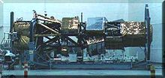](http://en.wikipedia.org/wiki/File:Lacrosse_sat.jpg)

U.S. Lacrosse radar spy satellite under construction

[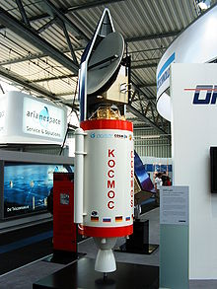](http://en.wikipedia.org/wiki/File:SAR-Lupe.jpg)

A model of a German SAR-Lupe reconnaissance satellite inside a Cosmos-3M rocket.

A spy satellite (officially referred to as a reconnaissance satellite) is an Earth observation satellite or communications satellite deployed for military or intelligence applications.

These are essentially space telescopes that are pointed toward the Earth instead of toward the stars. The first generation type (i.e. Corona and Zenit) took photographs, then ejected canisters of photographic film, which would descend to earth.

Corona capsules were retrieved in mid-air as they floated down on parachutes. Later spacecraft had digital imaging systems and downloaded the images via encrypted radio links.

In the United States, most information available is on programs that existed up to 1972. Some information about programs prior to that time are still classified, and a small trickle of information is available on subsequent missions.

A few up-to-date reconnaissance satellite images have been declassified on occasion, or leaked, as in the case of KH-11 photographs which were sent to *Jane's Defense Weekly* in 1985.

**Origins**

On March 16, 1955, the United States Air Force officially ordered the development of an advanced reconnaissance satellite to provide continuous surveillance of 'preselected areas of the earth' in order 'to determine the status of a potential enemy’s war-making capability'. In October 1957, the Russians launched Sputnik. It was the first man made object to be put into Earth's orbit.

**Missions**

Examples of reconnaissance satellite missions:

* High resolution photography (IMINT)
* Measurement and Signature Intelligence (MASINT)
* Communications eavesdropping (SIGINT)
* Covert communications
* Monitoring of nuclear test ban compliance (see National Technical Means)
* Detection of missile launches.